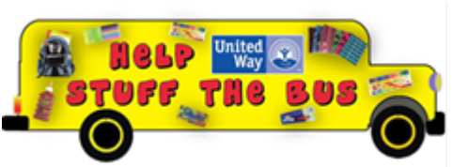

RE-UNITE WITH UNITED WAY’S
Stuff the Bus
&
Clothing Closet Campaign!

STUDENTS ARE RETURNING TO THE CLASSROOM!

What we do...
- Stuff the Bus is an outreach program of the United Way of Northern Cameron County to collect School Supplies and Gift Cards for New Clothing.
- This year marks our 11th annual campaign.
- Over the years, thousands of school-aged children have been helped.
- Funds and or Supplies are organized by and given directly to School Districts in our service area. School Districts have programs in place to best identify students in need.

Help us help them, a little goes a long way. As little as $5 will purchase pencil sharpeners for 5 students, $10 will purchase earphones for online learning, $20 could fill a backpack and a $25 Gift Card could go a long way in purchasing new clothing for the new school year.

Options for donating - Supplies or Monetary Donations accepted at our partners locations throughout the community. Check our Facebook page for updates on drop-off locations.

Monetary donations - Click on this link or "cut & paste link" to our Mobile Cause App
igfn.us/form/3Z8i5Q or Text: FULLBACKPACKS to 41444 on your Smart phone.

Mail your Stuff the Bus Donation to,
United Way of Northern Cameron County
PO Box 531227
Harlingen, TX 78553-1227

All Funds and Supplies will be distributed to School Districts and shelters in our Service area.

Jennifer Allen
Executive Director
956-423-5954

Kathy Preddy
VOLUNTEER

