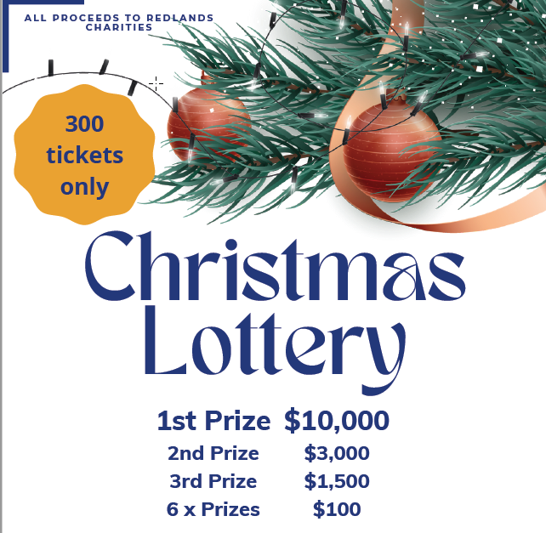
Ticket price: $100.00 each – 300 tickets only – Drawn December 16th at Christmas By Starlight, Cleveland Showgrounds
Paying by Direct Debit – tickets will be delivered or posted
NAME
ADDRESS
EMAIL
PHONE
PAY TO | Rotary Club of Cleveland Service Account
 | BSB: 034 070 ACCT: 603283
 | Reference: Lottery & your surname
 | Amount: $ Date of payment:

Paying by Credit Card – tickets will be delivered or posted
CREDIT CARD NUMBER
EXPIRY DATE | _____/_____ CVC:
NAME ON CARD
AMOUNT | $
PURCHASER’S ADDRESS
EMAIL
PHONE
Please scan or copy and send to secretary@clevelandrotary.org.au or shirleymahon2013@gmail.com for processing. Thanks for your support!

