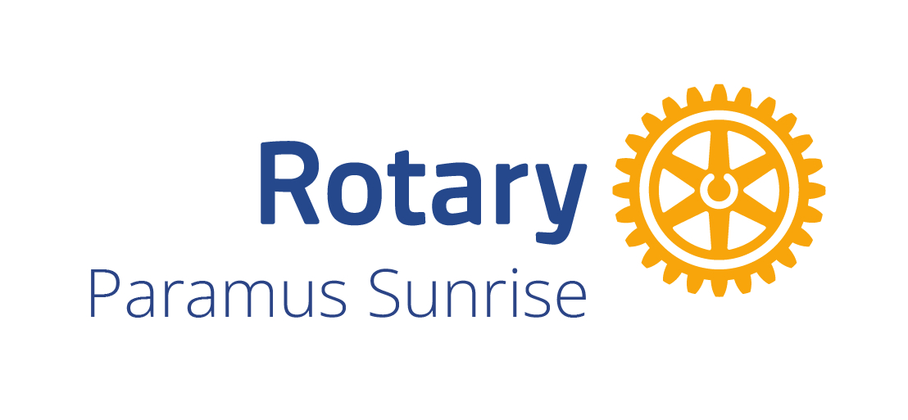 | PARAMUS SUNRISE ROTARY CLUB  2026 Paramus Kids Talent Show & Costume Contest  AD JOURNAL SPONSORSHIP & DEDICATION FORM
Event Date: Saturday, November 21, 2026 | 5:00 PM–8:00 PM  West Brook Middle School Auditorium • 560 Roosevelt Boulevard, Paramus, NJ 07652  DEADLINE TO SUBMIT FORM AND PAYMENT: NOVEMBER 7, 2026  Submit completed form to: paramussunriserotary@gmail.com |  | 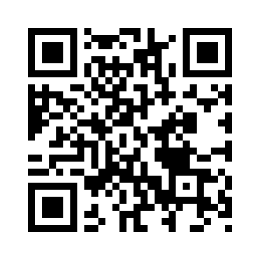

Support the event with a business advertisement or personal dedication. Select your preferred size and printing option below.
ADVERTISEMENT / DEDICATION OPTIONS
Size | Color printing | Black & white printing
Full page (7.5” W × 10” H) | $200 | $150
Half page (7.5” W × 4.75” H) | $100 | $75
Quarter page (3.5” W × 4.75” H) | $50 | $35
Select one: ☐ Full page color ☐ Half page color ☐ Quarter page color
☐ Full page B&W ☐ Half page B&W ☐ Quarter page B&W
Ad type: ☐ Business advertisement ☐ Personal dedication
CONTACT INFORMATION
Contact person*: _______________________________________________________
Business / organization (for ads): _____________________________________
Daytime phone*: ________________________________________________________
Street address (for ads): ______________________________________________
City / state / ZIP: ____________________________________________________
Email*: ________________________________________________________________
Website (optional): ____________________________________________________
SUBMISSION & PAYMENT
Send your finished ad or dedication as a PDF or JPEG to paramussunriserotary@gmail.com.
Pay by Zelle: Send payment to: paramussunriserotary@gmail.com
Pay by Check: Make checks payable to: Paramus Sunrise Rotary Foundation
Event information: www.ParamusSunriseRotary.com
The event benefits the Children’s Foundation. Thank you for your support!

