 AUCTION PRIZE

PAKURANGA ROTARY IN ASSOCIATION
WITH SIMON GAULT

Master the Art of Risotto
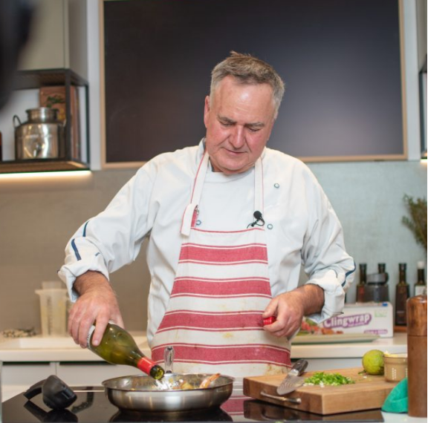
Calling all food lovers! Join world-renowned chef Simon Gault for a Mastering the Art of Risotto class at Gault’s Deli. Whether you’re looking to elevate your cooking skills or simply want to indulge in the rich, creamy flavours of authentic Italian risotto, this class is your ticket to culinary success. Simon will guide you through the secrets of perfect risotto, sharing techniques, tips, and his signature humour along the way. Best of all, you’ll get to enjoy the gourmet risotto prepared during the class – so come hungry!
Details:
- Location: Gault’s Deli, 3 Hannigan Drive, St Johns, Auckland
- Date & Time: To be booked for a lunch class Tuesday – Saturday dependant on Simon’s availability.
- Value: $700.00
- Class Size: 10 guests.
- Terms & Conditions: To be redeemed prior to 31st of October, 2025.
- Email admin@simongault.com to check availability and book your date.
- AUCTION PROCEEDS TO BELLYFUL EAST AUCKLAND

